## Setting the Sign Icons Size in the Palette

You can change the size of the signs in the palette. This is helpful when using a screen at very high resolution, or just for users who are having difficulty with the small icons. By default the sign icon size on the palette is set to medium.

**To change the signs icon size:**

* Click on the bar at the base of the Signs palette to make options appear.
* The size bar will pop up enabling you to select a different size (see below).
* 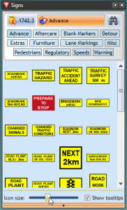
* Icon_Size_Bar